Dear Parents, October 17, 2014

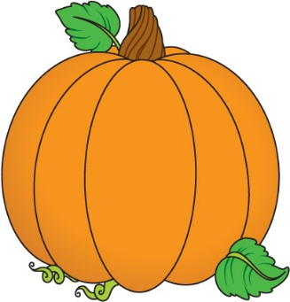Wednesday was the last day of the first quarter (42 days)! Wow, the year is going by so fast and the students are eager to learn many new things. We’ve spent this past week learning about the growing stages and parts of a pumpkin, reading many exciting stories about pumpkins as well as exploring at a pumpkin first hand!

This week we met Ms. Pp and she has perfectly pointy patches! We emphasized the /p/ sound as in pat, pan, purple, pickle, and Perryman (Bryce’s last name). We focused on looking for the letter Pp and the sound /p/ in our classroom, objects, books, and worksheets. We listed words that begin with the letter Pp such as pig, parrot, pink, purple, pumpkin, and popcorn. Ask your child to point to different objects or words that start with the letter Pp.

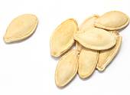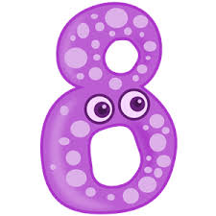In Math we explored numbers seven and eight. The students seem to like learning each poem that helps associate the number ☺ Please continue to practice these poems with your child at home. Along with exploring seven and eight, the students solved addition story problems about pumpkins and pumpkin pie. The students use counters (manipulatives) to help solve the problem. It’s so neat to see some children can solve it in different way and use different thinking/strategies but still end up with the correct answer ☺

We ended our week with a great field trip to Autumn Grove Apple Orchard. The students had a blast learning more about apples, picking the apples, and being creative with crafts. Thank you to all the parents who volunteered their time to help us out ☺ We certainly appreciate the extra hands ☺

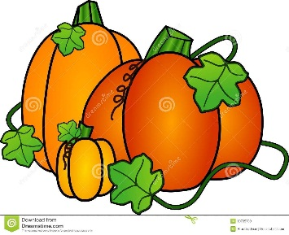Next week we will continue our pumpkin unit. Our letter of the week will be letter Zz. In Math we will continue to explore with numbers by making estimations, using measurement and height, and use 2D shapes to make our own jack-o-lantern ☺

Have a safe and wonderful weekend.

Mrs. Galles

**Next Week:**

Letter: Zz

Color: Brown

Everyday words: they

Math: numbers 9 and 10 and exploring pumpkins using shapes, height, and weight.

**Upcoming Events:**

* **Tuesday, Oct. 28th:**  Please send one small sized pumpkin to school with your child (it must fit in their back pack) for our fall festival party by Tuesday, Oct. 28th.
* **Fall Festival Party:** Friday, Oct. 31st (no costumes may be worn to school) from 11:30 – 12:30. If you would like to volunteer or help plan ideas for the party, please send me an email. I’ll be sure to include you on our list ☺
* **Early Dismissal:** Wed.Nov. 5th @ 1:30 Elem. only Professional Development Day.
* **NO SCHOOL:** Monday, Nov. 10th (Veteran’s Day Observed).
* **Early Dismissal:** Wed. Nov. 19th @ 1:30 All Buildings. Professional Development Day.
* **Early Dismissal/NO SCHOOL:** Wed. Nov. 26th @ 1:30 for Thanksgiving Holiday. NO SCHOOL Thurs. Nov. 27 – Fri. Nov. 28th.
* **Early Dismissal:** Wed. Dec. 3rd @ 1:30 Elem. only Professional Development Day.
* **Jr K/Kindergarten Holiday Concert:** Thurs. Dec. 11th @ 6:30 High School Auditorium.
* **Early Dismissal:** Fri. Dec. 19th Winter Break Begins
* **Classes Resume:** Jan. 5th (Beginning 3rd Quarter)

**Kindervention:**

**Week of Aug 25th:** Letter Mm **Everyday words:** I, like, to

**Week of Sept. 2nd:** Letter Tt **Everyday words:** and, are, you

**Week of Sept. 8th:** Letter Ff **Everyday words:** do, see, the

**Week of Sept. 15th:** Letter Nn **Everyday words:** made, my

**Week of Sept. 23rd:** Letter Hh **Everyday words:** is, there

**Week of Sept. 30th:** Letter review **Everyday words:** review

**Week of Oct. 6th:** Letter Aa **Everyday words:** me

**Week of Oct. 13th:** Letter Pp **Everyday words:** a, on

**Week of Oct. 20th:** Letter Zz **Everyday words:** they